**Project Report**

**Subject Name: Full Stack Java Programming (AIVSECL301)**

**Project Report on: “Smart Billing System”**

**College: Lokmanya Tilak College of Engineering, Navi Mumbai, Maharashtra, India, specifically at Sector 4, Vikas Nagar, Koparkhairane.**

**Prepared By: Karan Singh (A154)**

**Date: Wednesday, 01 October 2025**

Abstract**:**

The Smart Billing System is a desktop application designed to automate billing processes in retail stores. It simplifies product entry, manages customer data, calculates tax and discounts, and generates bills in a user-friendly interface. The project demonstrates the use of Java Swing for the GUI and standard Java libraries for logic implementation. This application helps reduce manual errors and enhances operational efficiency.

**Table Of Contents:**

**1. Title Page**

**2. Abstract**

**3. Table of Contents**

**4. Introduction**

**5. Software & Hardware Used**

**6. System Design / Flowchart**

**7. Future Scope**

**8. Results & Discussion**

**9. Conclusion**

**Introduction**

In traditional retail stores, billing is done manually, which is time-consuming and prone to errors. The Smart Billing System project aims to digitize and simplify this process by providing an easy-to-use desktop application that handles product entries, calculates subtotals, tax, discounts, and generates printable bills.

**Software:**• Java Development Kit (JDK)

• Eclipse

• Swing Framework (for GUI)

**Hardware:**• PC or Laptop with minimum 4 GB RAM

• Windows Operating System

• Printer (optional for physical bill print)

**System design**

The Smart Billing System is designed using a modular approach. Each module performs a specific function and interacts with others to ensure smooth workflow. The system design is divided into the following layers:  
  
1. User Interface Layer (UI):  
 • Developed using Java Swing.  
 • Allows customers' details and product details to be entered.  
 • Provides options to add, remove products, calculate totals, and print bills.  
  
2. Application Logic Layer:  
 • Handles business logic such as:  
 - Calculating subtotal, tax, discount, and grand total.  
 - Generating unique bill numbers.  
 - Validating customer and product data.  
 • Ensures accuracy in billing.  
  
3. Data Storage Layer:  
 • Bill details are saved in text files (e.g., Bill_1001.txt).  
 • Each file stores customer details, products purchased, and final totals.  
 • This enables future reference and record keeping.  
  
4. System Output:  
 • Displays the generated bill in a dialog box (JOptionPane).  
 • Saves the bill in a text file for customer/owner record.

**Flowchart:**

**Future Scope:**

Implement database connectivity to store bills. Add login and authentication for multiple users. Enhance UI for better user experience. Implement multi-currency support. Add export options for PDF, CSV, and Excel formats in future versions.

**Result:**

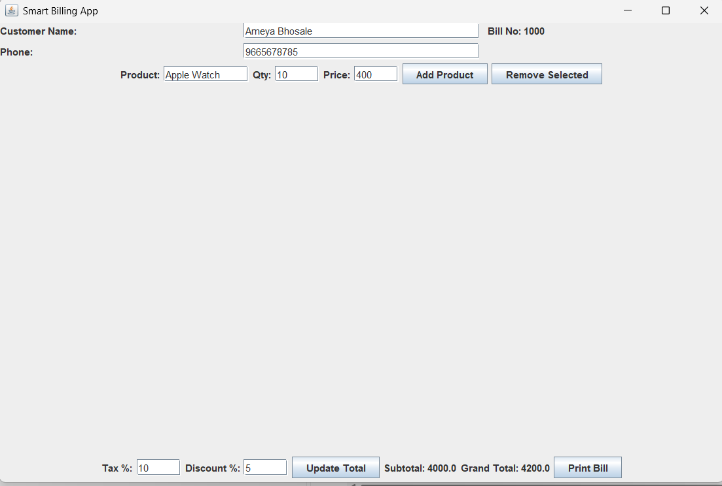

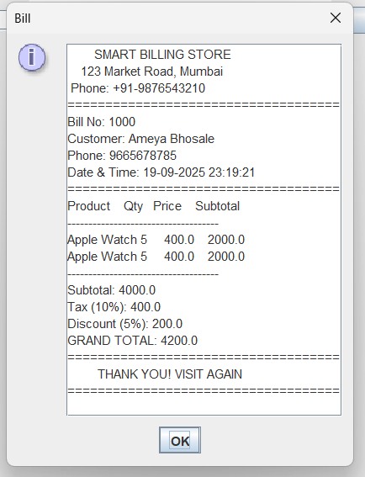

**Conclusion**

The Smart Billing System automates retail billing, improving accuracy, saving time, and ensuring reliable records. It is scalable, with scope for features like inventory management and user authentication. Currently, it generates bills as .txt files, which are simple to view, share, and print.